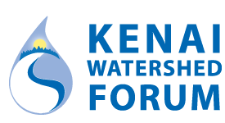

“Research, Restoration, Education”

Benjamin Meyer | Water Quality Coordinator | ben@kenaiwatershed.org | (907) 232-0280

KENAI RIVER BASELINE WATER QUALITY MONITORING

SAMPLE COLLECTION PROCEDURES

Fieldwork Preparation ………………………………………………………………….1

General Sampling Protocol ……………………………………………………………..2

Preparing for Sample Collection………………………………………………………..2

Sample Collection Procedures by Sample Type………………………………………..3

Fecal Coliform …………………………………………………………………...3

Dissolved Metals …………………………………………………………………4

BTEX (Hydrocarbons) ………………………………………………………….5

Total metals ……………………………………………………………………...6

Nitrogen and Phosphorus ………………………………………………………6

Total Suspended Solids …………………………………………………………7

Appendix A – Clean Hands, Dirty Hands ……………………………………………..8

FIELDWORK PREPARATION

Six weeks prior to sampling date

The water quality coordinator will contact you by email. Please RSVP as soon as possible if you are participating.

One week prior to sampling date

Confirm plans with you fieldwork partners and supervisor.

Know meeting time and place.

Review current sampling protocol (this document).

Ask the Water Quality Coordinator if you have questions (see top of this form for contact info).

One day prior to sampling date

At least one team member will pick up water quality sampling equipment from the Water Quality Coordinator. Your confirmation email will describe pick-up time and location.

Keep ice packs for the sample cooler frozen until the morning of sampling, put reminder note in car.

______________________________________________________________________________

GENERAL SAMPLING PROTOCOL

Once you’re at the site, there are some important things to do BEFORE opening the cooler.

At the site, make a judgment call as to whether the site is representative

Is the river bottom stirred up?

Is there something atypical, like a moose carcass just upstream?

Are other boats nearby?

If site at the coordinates are not representative, either wait until conditions return to normal or slightly modify location.

Leave cell phones turned on for project communications

Choose a collection location

Samples collected in the main stem of the river should be collected at least ten feet from the riverbank.

Samples collected from tributaries should be collected upstream of the mixing zone with the main stem.

Collect Site information

Use pre-printed Rite-in-the-Rain field forms to record data with a pencil

Record GPS coordinates on paper at each sampling location

You can use the Google Maps app on your smart phone to get coordinates even when out of cell reception. Ask the Water Quality Coordinator if you have questions how to do it.

Collect a photograph at each location with a person holding a sign indicating the sampling location.

Deploy water and air thermometers, take readings before you leave the site

Collect samples only from the assigned creek or river for your group

______________________________________________________________________________

PREPARING FOR SAMPLE COLLECTION

Once you’ve established that your sampling location is ready…

Prepare to use “Clean Hands / Dirty Hands” technique

NEW FOR 2022: Designate one person as “Clean Hands” who will only handle sample bottles, and one person as “Dirty Hands” who will perform all other steps. The water quality coordinator will provide training and explanation on clean hands / dirty hands technique on sample kit pick-up day. See Appendix A for further detail.

Prepare sample labels

Write on bottle label stickers prior to applying them to the bottles, and apply them to the bottles before they are wet. (Labels are waterproof).

Other sample label notes

Complete the fields on the bottle labels for TIME and INITIALS.

INITIALS should be those of the team leader only.

Use the IDENTICAL TIME for all sample containers at a site.

Sites are designated with Kenai River main stem River Mile (RM) and site name.

Duplicate samples are indicated by using the abbreviation DUP, as in “RM 10 – Site name - DUP.”

If necessary, write additional information with a black sharpie on plastic HDPE bottles.

Do NOT use sharpies on the hydrocarbon (BTEX) samples vials, they will contaminate the sample.

Other General Sampling Notes

Put on new clean gloves if you suspect contamination at any point in sampling process.

In general always, ensure that the inside of the bottle caps are not contaminated:

Do not put bottle caps in your pocket.

Do not touch inside of cap or bottle.

Employ “Clean Hands / Dirty Hands” technique throughout sampling process. The water quality coordinator will provide a demonstration on cooler pick-up day. See Appendix A of this document for more details.

When sample collection is complete at all sites, return to sample drop-off location in Soldotna as quickly as feasible.

Some samples cannot be analyzed if they exceed a holding period, thus timely delivery is important!!!

If your route to the next sampling site passes by the sample drop-off location, please drop them off even if you are not yet done for the day.

Thank you!!!!

______________________________________________________________________________

SAMPLE COLLECTION PROCEDURES BY SAMPLE TYPE

Fecal coliform is a bacteria that exists naturally in the wild that is found in feces of warm-blooded animals. It can reach elevated levels when animals concentrate, like gulls flocking to carcasses, or from human sources, such as a leaking septic tank.

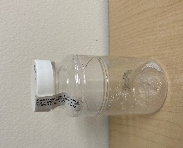

Collect the “Fecal Coliform” sample.

The fecal coliform bottle is 100 ml clear plastic bottle with white powder (sodium thiosulfate-fixing agent) and may have a labeled paper seal over the lid. The lid may be labeled “FC.”

Break the seal, either plastic or paper

Record sampling time and crew leader initials on the label and apply to bottle.

Carefully open the container, keeping the lid in one hand and the bottle in the other hand.

Do not touch the inside of the bottle or lid.

Always collect samples facing upstream with the flow of the river coming at you.

Fill the sample bottle with one smooth motion to just over the 100 ml mark. It is necessary to leave some room in the bottle because it will have to be inverted 25 X in the lab.

Place sealed bottle in cooler with ice.

****************************************************************************

Dissolved metals refers to substances such as zinc, copper, lead, arsenic, and others that exist in a soluble (dissolved) form in water. These elements exist naturally in the environment in rocks and soils, and also have anthropogenic sources such as runoff from roads and agriculture, industrial processes, and fuel combustion.

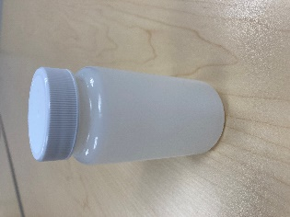

Not all sites collect dissolved metals samples. Check your kit packing list to see if your sites do.

PLEASE NOTE NEW CHANGES TO DISSOLVED METALS COLLECTION BEGINNING JULY 2022:

No filtration in the field is required for any samples. The dissolved metals sample will be filtered in the lab. No syringes or filters are provided.

Collect the “Dissolved Metals” sample (if applicable)

Please note, only sites including and downstream of RM 30 will sample for dissolved metals.

Proceed to Step 3 if no dissolved metals sample is to be collected.

The dissolved metals sample collection bottle is a 250 ml plastic bottle with a red sticker (denoting HNO₃; Nitric acid)

Record sampling time and crew leader initials on the label and apply to bottle.

Do not rinse this bottle.

Fill the TSS bottle (1 L plastic bottle) using a slow sweeping motion at a depth of six inches.

Remove the cap of the dissolved metals bottle. Fill this bottle to the shoulder with sample water from the 1 L TSS bottle, then replace the caps on both bottles.

Place dissolved metals bottle in cooler with ice.

****************************************************************************

Hydrocarbons (BTEX) are substances found in petroleum products, such as fuel for boats and vehicles. These substances can enter the water from several sources including older or improperly maintained boat engines, fuel leaks from homes or vehicles, and products such as paints and plastics. BTEX stands for benzene, toluene, ethylbenzene, and xylene.

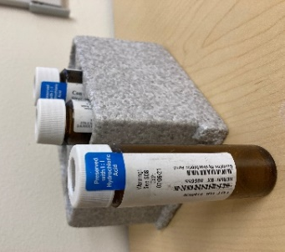

Hydrocarbon samples are collected in Summer only, not Spring, and not all sites collect these samples. Check to see if your kit does. This is our most detail-oriented type of sample collection, so proceed carefully.

Please note, only RM 1.5, 6.5, 40 and 43 sites will be sampled for BTEX and only during summer (not spring) sampling events!

Proceed to Step 4 if no BTEX sample is to be collected

The BTEX sample vials are three 40 ml brown glass vials preserved with hydrochloric acid (HCl)

Record sampling time, crew leader initials, and vial sequence (# of 3) on the label and apply to the vials lengthwise.

Do not rinse these vials.

Fill the 1 L TSS bottle with sample water:

Face upstream with the flow of the river coming at you.

Remove the lid, turn the bottle upside down, go to a depth of 6”, and allow the bottle to fill, remove the bottle from the water, and discard a small amount so that the fluid level reaches the shoulder of the bottle.

Carefully fill all three 40 ml vials until a mound of water (meniscus) is formed on top of the vial.

Do not overflow the vials excessively as they contain Hydrochloric Acid (HCl) as a preservative.

Cap the vials and place in cooler with ice.

Special notes concerning the collection of BTEX samples.

For BTEX-Volatile Organics Compounds (VOC)- it is critically important to NOT have any air bubbles (or headspace) in the vials after sampling.

Sampling Teams using a boat

Have a designated driver and only the driver handles gas can and drives the motor.

Boat driver does not handle BTEX Bottles.

All teams

If you filled up a vehicle with gas the day of sampling, do not handle the BTEX vials.

Avoid handling or contact with all chemicals and/or solvents.

****************************************************************************

Total metals includes all the metals within a water sample, including BOTH dissolved metals AND non-soluble (particulate) metals. These elements, including zinc, copper, lead, arsenic, and others exist naturally in the environment in rocks and soils, and also have anthropogenic sources such as runoff from roads and agriculture, industrial processes, and fuel combustion.

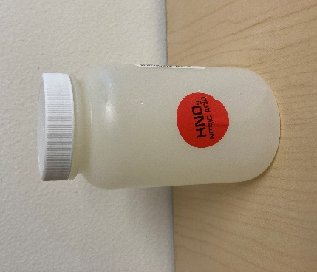

Collect the unfiltered “Total Metals” sample

The unfiltered total metals sample collection bottle is a 250 ml plastic bottle with a red sticker (denoting HNO₃; Nitric acid)

Record sampling time and crew leader initials on the label and apply to bottle.

Do not rinse this bottle.

Remove the cap, fill the bottle to the shoulder with sample water from the TSS bottle, and replace the cap.

Place bottle in cooler with ice.

****************************************************************************

Nitrogen and phosphorus are essential for plant and animal growth and nourishment, but the overabundance in water can cause adverse health and ecological effects. Although nitrogen and phosphorus are abundant naturally in the environment, they are also introduced through sewage and fertilizers.

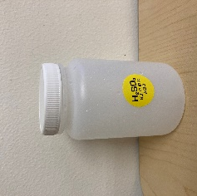

Collect the Nitrate+Nitrite/Total Phosphorus sample

The Nitrate+Nitrite/Total Phosphorus bottle is a 250 ml plastic bottle, with a yellow sticker (denoting H₂SO₄, sulfuric acid)

Record sampling time and crew leader initials on the label and apply to bottle.

Remove the cap, fill the bottle to the shoulder with sample water from the TSS bottle, and replace the cap.

Place bottle in cooler with ice.

****************************************************************************

Total Suspended Solids, or TSS, stands for total suspended solids, and refers to waterborne particles that exceed 2 microns in size. TSS commonly consists of items like clay, gravel, sand, silt, and vegetation. TSS can increase due to erosion, algae growth, and sediment disruption. TSS levels can affect dissolved oxygen content, which affects aquatic life like fish.

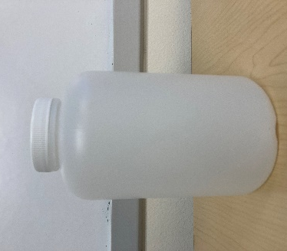

Collect the “TSS”-Total Suspended Solids

The Total Suspended Solids bottle is a 1 L plastic bottle

Record sampling time and crew leader initials on the label and apply to bottle.

Fill the TSS bottle with the same methods outlined in the “Dissolved Metals” Section.

Cap the bottle and place bottle in cooler with ice.

Appendix A: “Clean Hands, Dirty Hands” Sampling Technique

What is ‘Clean Hands, Dirty Hands’ (CHDH)?
The Clean Hands Dirty Hands sampling technique of EPA-1669 was developed for low level mercury testing but is often applied to trace metals sampling. This method minimizes potential sample contamination by designating one person to be ‘clean hands’ (CH) and another as ‘Dirty Hands’ (DH). DH handles all sampling equipment and CH handles all sample bottles.

Field Application
Clean Hands – The person designated as Clean Hands (CH) will handle the actual sample bottles. CH will fill and label the bottles. CH is responsible for keeping hands clean during sampling events, and changing gloves if contamination occurs. CH is responsible for communicating with other crew members to open coolers, handle sampling equipment, etc., as CH should not be handling any sampling items except for the sample bottles themselves.
Field Sampling Crew – The field sampling crew will be Dirty Hands (DH). DH will open/close the cooler, handle the sealed (in Ziplock) bag of sample bottles, handle the water collection bottle, and record data.
Boat Crew – The boat operator will be in contact with motor oil, galvanized metals, etc. and therefore should not be handling the actual sample bottles. The boat operator will be responsible for maintaining the boat in position for sampling and safely transporting the crew from one site to the next. The boat operator may help with data recording and other tasks as needed that do not involve directly handling sample bottles.

Required Preparation
• Practice makes perfect – The field sampling team will practice sample collection using the CHDH technique. At least one practice sample collection will be demonstrated on sample cooler pickup day, and the other on fieldwork day prior to the first sample collection.
• Pre-sampling preparation – Bottles will be carefully handled with gloved hands, labeled, and placed into double layer Ziplock bags. DO NOT open bottles before actual sample collection.
• Supplies – The Project Manager will make sure that the field team has enough nitrile gloves, Ziplocks and other tools required to complete field work.

Sunscreen, jewelry, and galvanized metals
• Many cosmetic products including sunscreen contain zinc. It’s important to protect you skin against UV, however if you wear sunscreen DO NOT touch your face during active sampling. If you do, change gloves, and start over. Alternatively, wear physical sun protection such as a sun hat, face mask/gaiter, long sleeved shirt, etc.
• Avoid wearing jewelry on your hands and/or wrists. Earrings and necklaces are fine, just avoid touching them during active sampling. If you touch metal jewelry, even if it’s not zinc based, change your gloves immediately.
• Galvanized metals are metals coated in zinc oxides. No one actively collecting samples should touch galvanized surfaces during active sample collection. If samplers accidentally touch galvanized metal they should stop, remove the contaminated gloves, and replace contaminated gloves with clean cloves.

Adapted from Appendix F in Apsens, S., and Petitt, J. 2022. Kenai River, Alaska Field Report 2021. Alaska Department of Environmental Conservation.

Duplicate samples at the same site are considered separate sampling events, and each set of duplicate samples will have a unique time associated with it.

