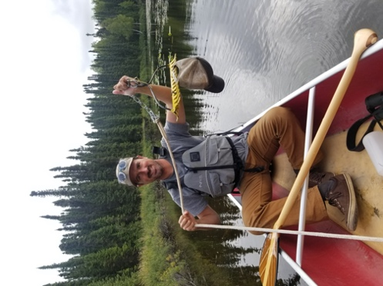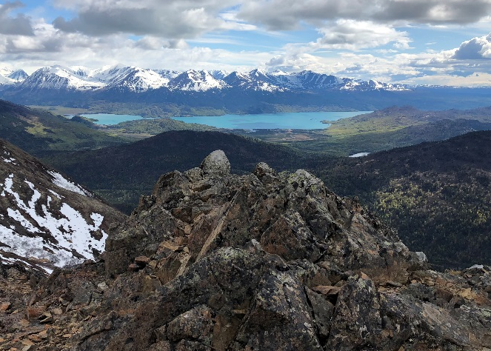

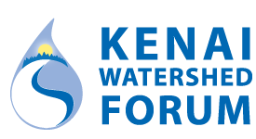
Position: Conservation Intern

Application Deadline: February 25, 2022, 12 pm AKST

Location: Soldotna, Alaska

Duration: May 1-June 1, 2022 through August (end date is negotiable). Possibility for extension through fall fieldwork season depending on applicant qualifications and needs of the program.

Hourly rate: $10.50/hr

General description: The Kenai Watershed Forum (KWF) is a nonprofit focused on maintaining healthy watersheds by way of invasive species management, environmental education, marine debris clean-up, river restoration, water quality monitoring, and fisheries research. KWF will be hiring several interns under different programs, whose tasks may include the following:
- Invasive species: assisting with invasive species management efforts (in both terrestrial and aquatic environments), plant ID, simple GIS mapping exercises, education/outreach, and data collection/reporting.
- Stream Watch: marine and freshwater clean-up events, coordination with volunteers, fisheries habitat education, river restoration projects, angler outreach, and data collection/reporting.

Qualifications: Limited to undergraduate college students (sophomore or above) in good academic standing studying environmental sciences, social sciences, communications, or other related fields.

Work Environment: Intern will conduct fieldwork with KWF staff and partner agency personnel, remaining flexible in both schedule and required tasks, as some cross training may be available. Comfort while working remotely in bear country required. Fieldwork may require backcountry hiking, heavy equipment transport, and occasionally-strenuous fieldwork in adverse conditions. Traveling by 4WD truck, 4-wheeler, and/or boat required; ability to tow/back a trailer helpful.

Benefits: Housing is provided and transportation to/from Alaska will be paid for. Vehicle will also be provided during “off” hours (may be shared with another intern); gas for personal activities will not be included. Intern must have valid driver’s license and clean driving record. Typical work week will be 40 hr/wk including some evenings and weekends with occasional overtime expected.

How to Apply: Please email a one-page cover letter and a one-page resume along with contact information for three references to intern@kenaiwatershed.org and indicate your preferred program. Applications not conforming to these requirements will not be considered. Please contact Rhonda McCormick by email regarding any further questions: rhonda@kenaiwatershed.org.

The Kenai Watershed Forum is a 501(c)(3) non-profit dedicated to maintaining the health of the watersheds on the Kenai Peninsula through education, restoration, and research programs. More information at: www.kenaiwatershed.org.

